

Asia Pacific College

#3 Humabon Place, Magallanes, Makati City 1232

VR Haunted Philippines

**Project Members:**

Carpio, Aira Joyce A.

Gardon, Jana Marie G.

Ferrer, Kenneth

**Course & Section:**  
BSIT MI-141

Engr. Noel Quizon Anonas

***Instructor in Mobile Programming***

Contents

**Chapter 1** 3

**Project Description** 3

**Target Audience and Market** 3

**Related Literature** 3

**Project Objectives** 3

**Scope and Limitations** 4

**Storyline** 4

**Chapter 2** 5

**Mechanics:** 5

**Instructions:** 5

**Cut Scene** 5

**Chapter 3** 6

**Technology used for App Development:** 6

**Diagrams** 6

**Use Case Diagram** 6

**Context Diagram** 6

**Project System Flow Diagram** 7

**Java Code Snippet** 7

**Chapter 4** 11

**Graphic Assets or Artwork Samples** 11

**Chapter 5** 12

**Lessons Learned** 12

**Chapter 6** 13

**Resume of each member** 13

# **Chapter 1**

## **Project Description**

Ph Haunted is a survival horror game that is based on one of the haunted houses in the Philippines, called Laperal White House. The game will focus on survival of the character as the game tries to frighten players with either horror graphics or scary ambience. Ph Haunted is a combination of playing and learning. It usually involves the investigation and confrontation of horrific forces and thus this game transform common elements from horror fiction into gameplay challenges. The player just need to tap all the ghost approaching, to keep himself alive or else the game will end. The player can escape the house, once he finds all the keys required.

## **Target Audience and Market**

The target audience and Market for Ph Haunted are those people who love survival horror game. This game is not just a horror game but the people who play this will also enjoy and learn something from this.

## **Related Literature**

Tap Tap Ghost

Catch Norton, the ghost of this game. Tap Tap The Ghost is a very fun game where you have to hunt Norton the Ghost. All you have to do is tap Norton the Ghost. Norton the Ghost will try to escape from your taps. Collect some magic potions along the game to get more boosts but be careful! Avoid at all time the bad demons that will make you lose a life!

Tap Tap The Ghost

The ghosts are roaming everywhere. They disturb the peace of the people in surrounding cemetery. Help people to repel the ghost by tapping it quickly and e careful with the bombs or dynamites!

## **Project Objectives**

The objectives of Haunted PH are the following:

* To explore the Laperal White House
* To know the tragic story and history of Laperal White House
* To learn and have fun at the same time

## **Scope and Limitations**

Ph Haunted is open for everyone unless a particular game sets an age limit. Ph Haunted suits for the audience that are interested in horror and mysteries. This game doesn’t require internet connection to play.

Due to lack of time, Ph Haunted is only limited to one location. The user has to survive, as he/she enters to one of the popular haunted houses in the Philippines. Only players ages 10 and above is allowed to play the game as it contains scary effects and horrifying atmosphere.

## **Storyline**

One of the haunted houses found in the Philippines is Laperal White House, that specifically located in Baguio City. Just like other haunted houses, it remains uninhabited except for the caretaker who lives outside the house within the gates. The tragic story happened when the Laperal family, the oldest clan in Baguio, was brutally murdered inside the house by the Spanish soldiers. The Laperal White House is full of history and unshared stories. Some says that once you enter the house, there is no way to go out.

One night, a guy who loves to travel and explore new things, makes a documentary about the different places in the Philippines. Out of curiosity, he entered the Laperal house. Little did he know that according to the story, no one can escape once they enter the house. The guy was locked inside the haunted house and the only way he can escape is by finding the key while avoiding all the ghost.

# **Chapter 2**

## **Mechanics:**

You are locked inside the Laperal house at the middle of the night, your main goal is to escape while being attacked by the ghosts. Get rid of the ghost by tapping the ghost as fast as you can before they come near you. Get all the keys asked to use as an escape from the house. But before you can totally be free from the house, you have to pass all the levels. The haunted house is surrounded by ghost and the creepy sounds and effects makes the player both as nervous and uncomfortable as possible.

## **Instructions:**

1. Avoid the ghost as they are approaching towards you to avoid losing your life.
2. Repel all ghost by tapping them quickly
3. Find the key/s
4. Get the key/s
5. Escape the haunted house

## **Cut Scene**

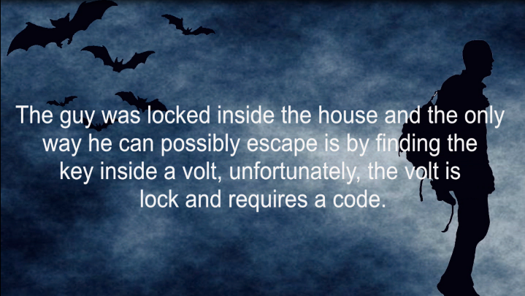

The start of the storyboard The end of the storyboard

## **Game Map/Levels**

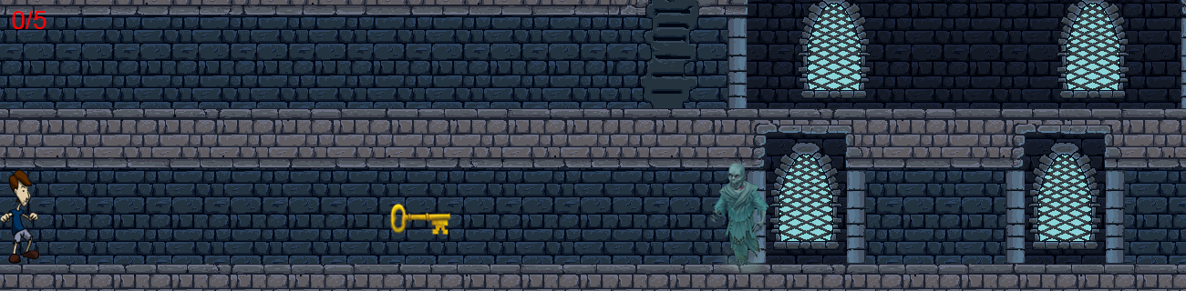

Level 1

The number on the upper right portion of the screen indicates how many key the user has to get to end the level. While the user collects key, ghost will keep on coming towards him.

# **Chapter 3**

## **Technology used for App Development:**

* Android Studio
* Adobe Photoshop
* Sony Vegas
* After Effects

## **Diagrams**

### **Use Case Diagram**

### **Context Diagram**

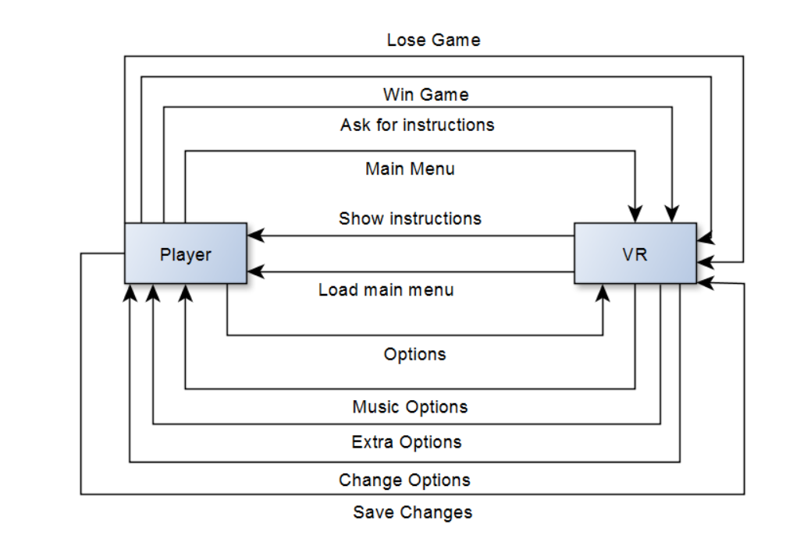

### **Project System Flow Diagram**

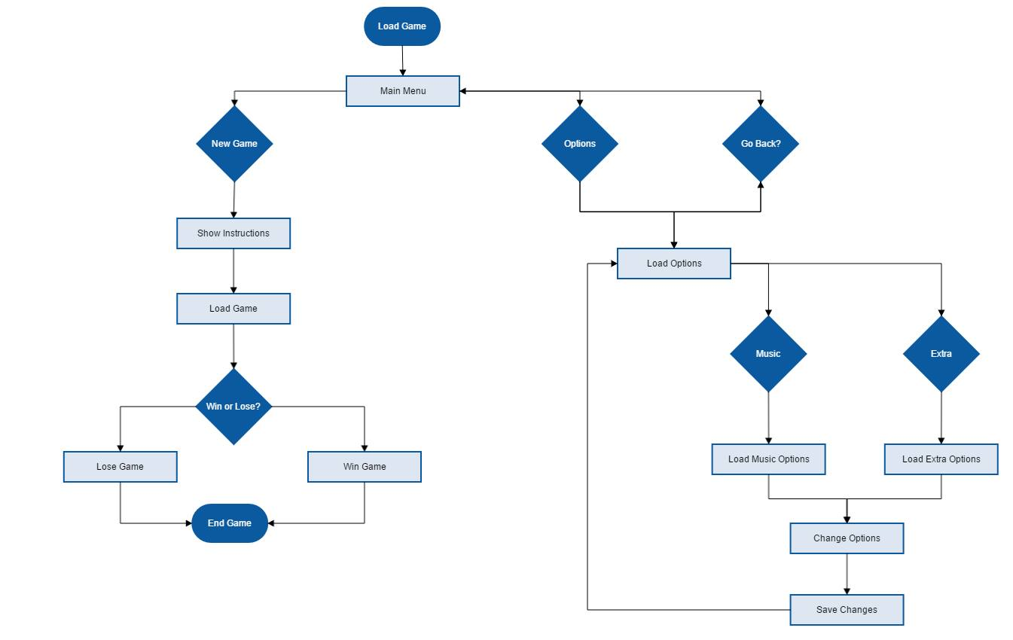

## **Java Code Snippet**

Splash Screen

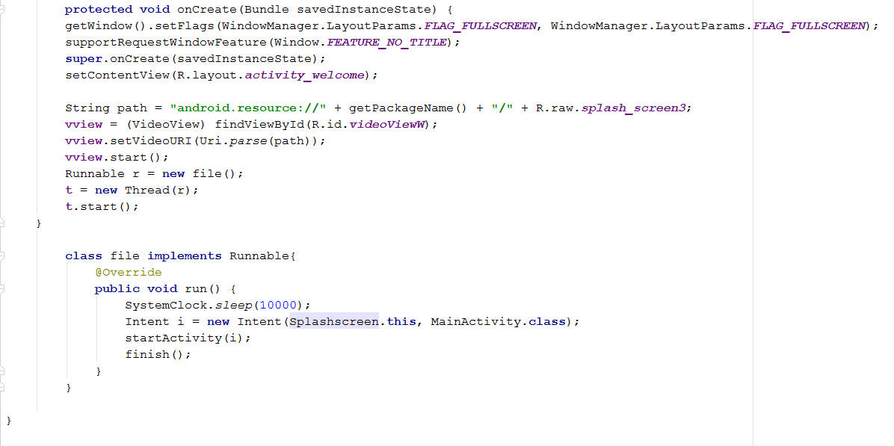

Main Activity

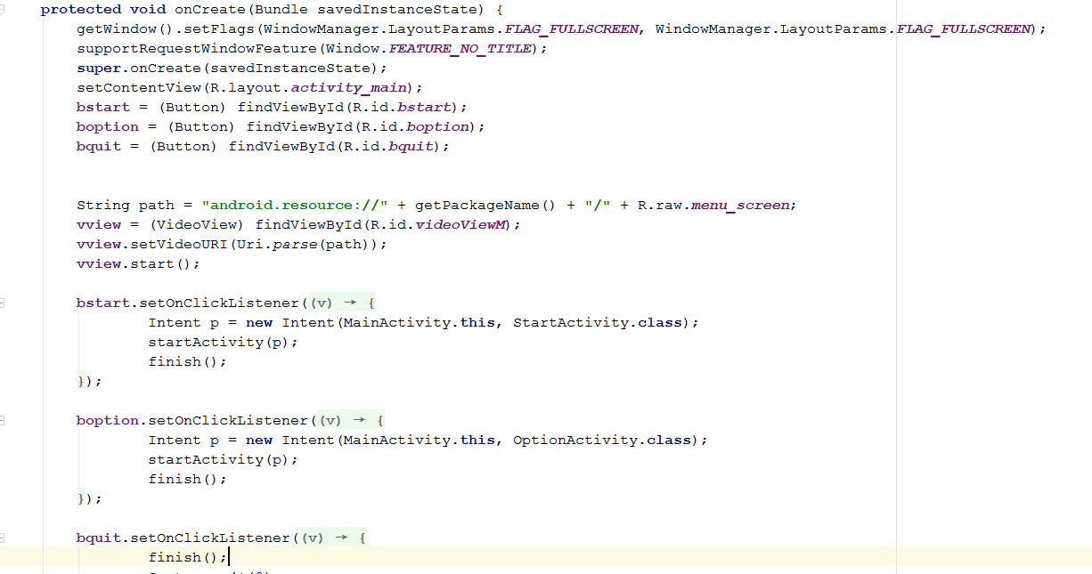

Start Activity

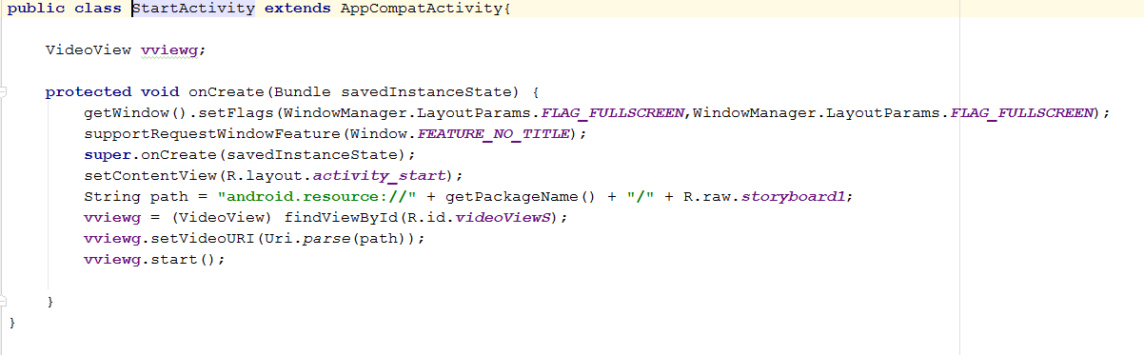

Quit Activity

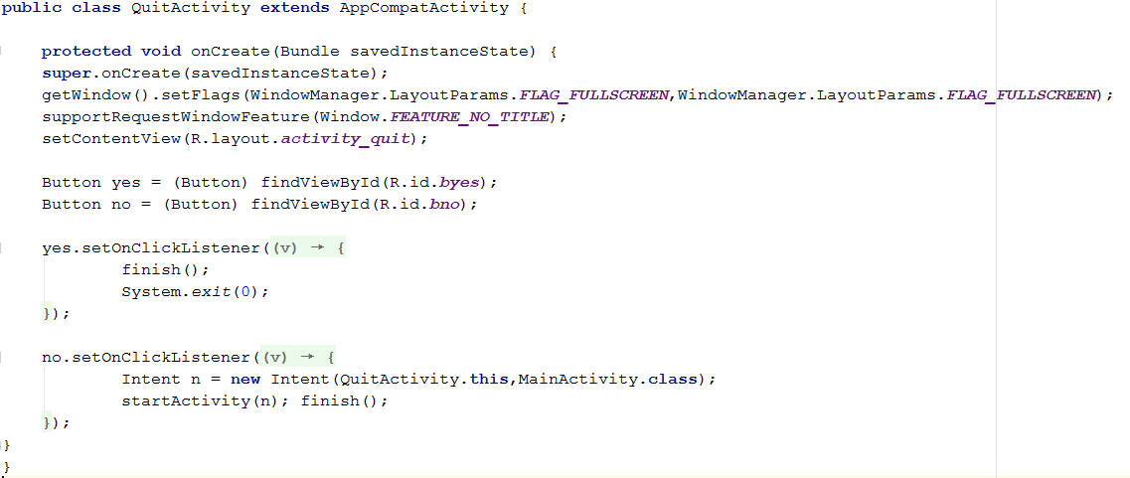

Option Activity

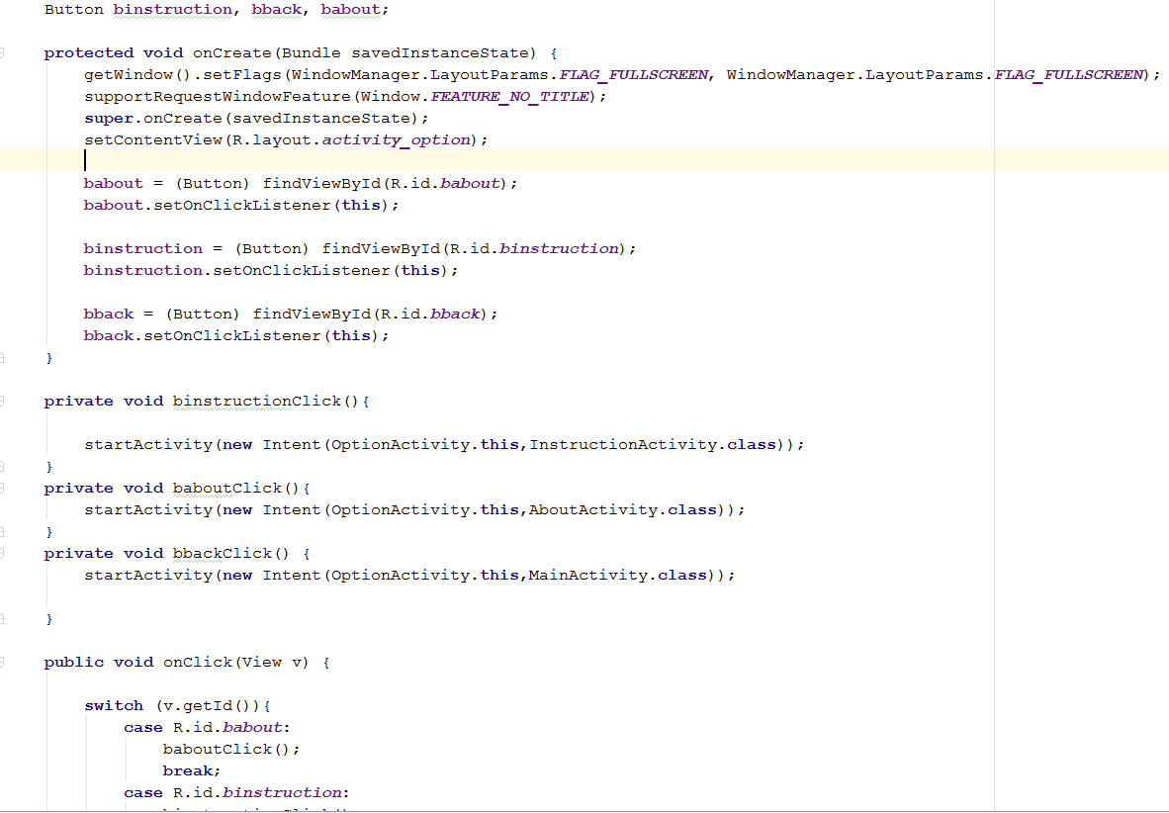

Instruction Activity

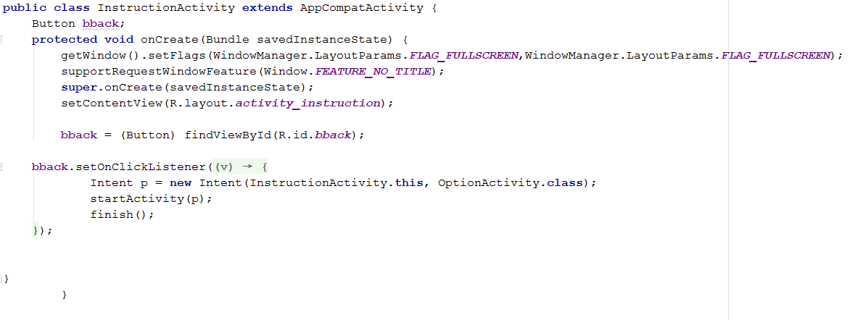

About Activity

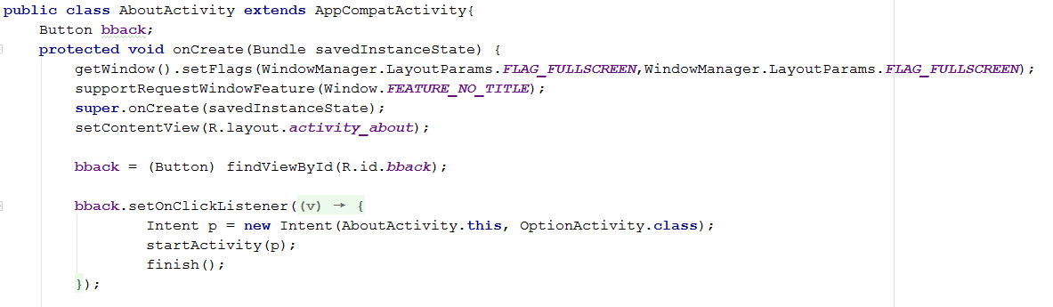

# **Chapter 4**

## C:\Users\Jana Marie Gardon\Documents\3rdyr-1stterm\Mobprog\Project\Final\Final\PhHaunted\MyApplication\app\src\main\res\drawable\menuscreen.png**Graphic Assets or Artwork Samples**C:\Users\Jana Marie Gardon\Documents\3rdyr-1stterm\Mobprog\Project\Final\Final\PhHaunted\MyApplication\app\src\main\res\drawable\splashscreen.jpg

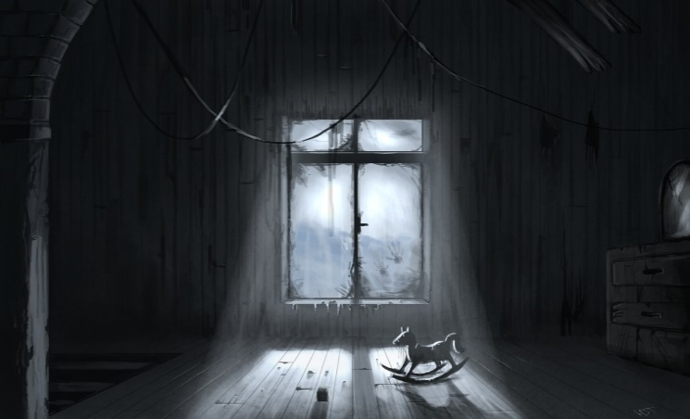

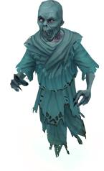

****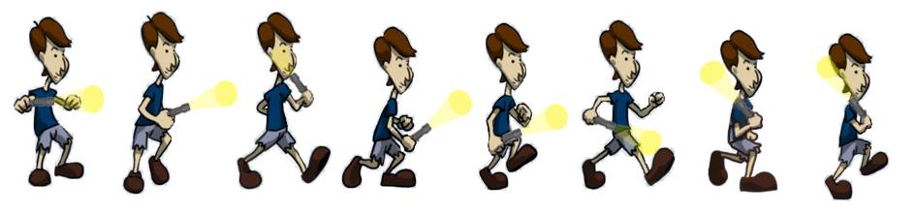

# 

# 

# **Chapter 5**

## **Lessons Learned**

Creating your own game, sounds interesting and exciting, but for us IT students, in every excitement there is always an equivalent hardship because we know firsthand that it is not easy to build a successful app especially if there is no enough time. A group that has a determination to finish the app and have patience has a chance to build a successful application.

Building this app has been educational. Moving from ideation to coding on a small group, we got a great deal of help from others, and from tools available. Along the way, we discover ideas and codes, we haven’t encountered yet that is a good addition to our knowledge about Java. Of course we’ve taken in a considerable measure about how our accomplices fabricate applications and tackle issues. Though we changed our app from VR to Standard game, at least we know that we can do it, just that we don’t have enough tools and time for it. Moreover, managing our time is the key to avoid cramming.

Players that will use our app, will learn the story behind the Laperal White House and while playing they will enhance their strategy.

# **Chapter 6**

## **Resume of each member**

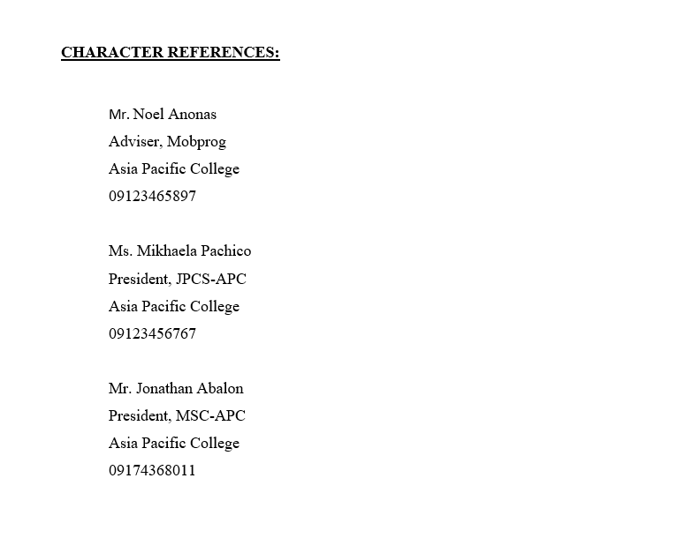 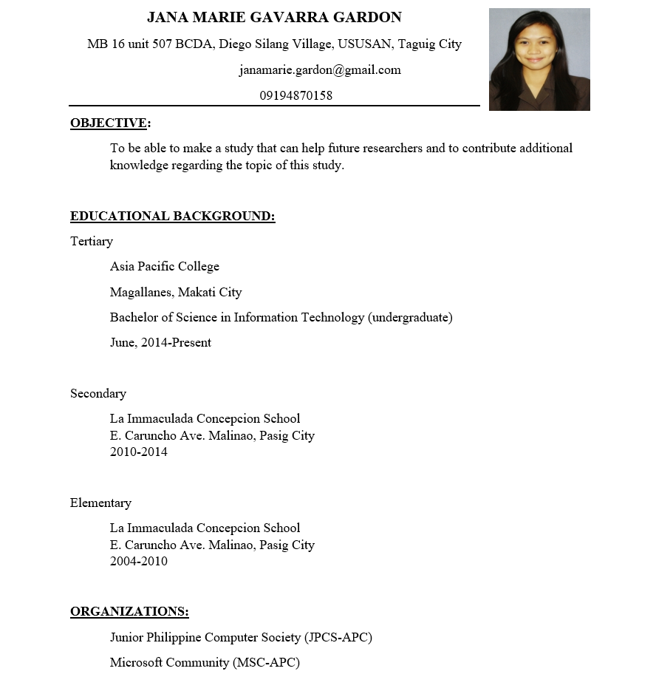

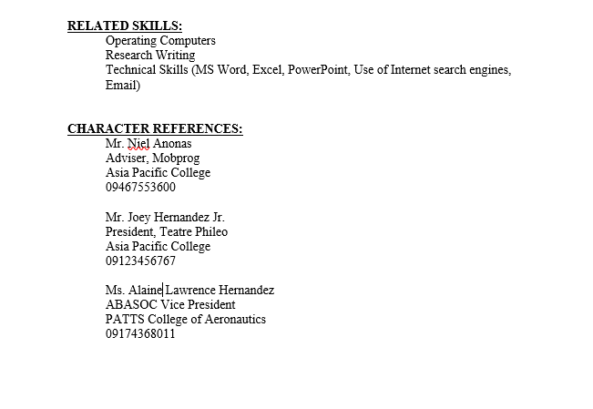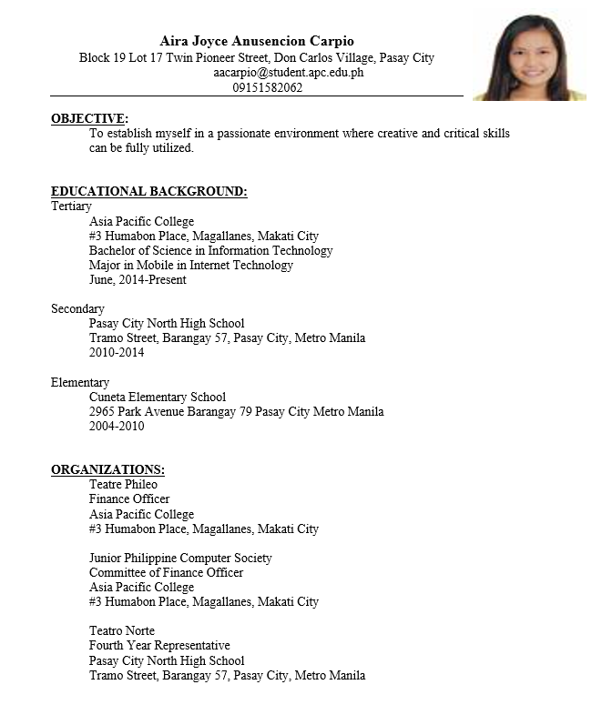

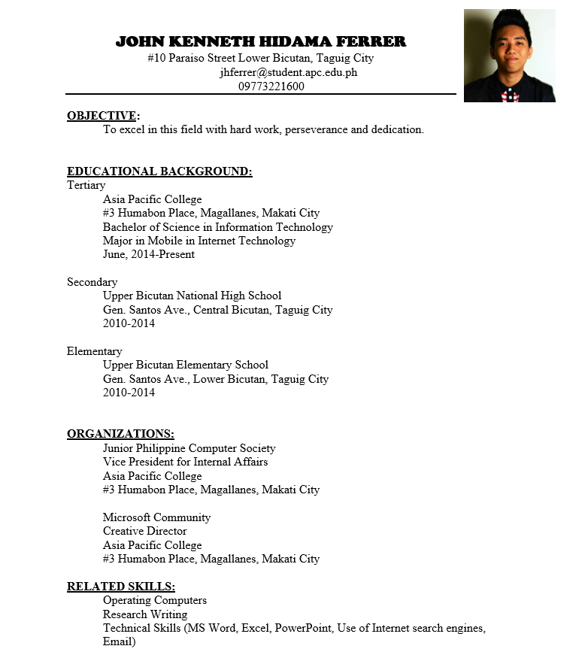

**Work Summary**

|  |  |  |  |
| --- | --- | --- | --- |
| **DATE** | **NAME** | **ROLES** | **DESCRIPTION** |
|  | Jana Marie Gardon | Documentation and Programmer | Provide documents for the project and combined all the requirements for the final documentation.  Program the game |
|  | Aira Joyce Carpio | Lead Programmer | Program the game |
|  | John Kenneth Ferrer | Designer | Provide the design for the game |

**Revision Page**

|  |  |  |  |
| --- | --- | --- | --- |
| **DATE** | **Version** | **Accomplishment** | **Name** |
| **8/23/16** | V2.1 | Documentation  Music | Jana Marie Gardon |
| **8/23/16** | V2.1 | Game Map/Level  Level 1  Main Screen | Aira Joyce Carpio |
| **8/23/16** | V2.1 | Background | Kenneth Ferrer |